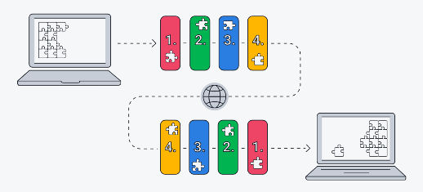TCP/IP is just a list of rules or guidelines standards on how computer can communicate with each other

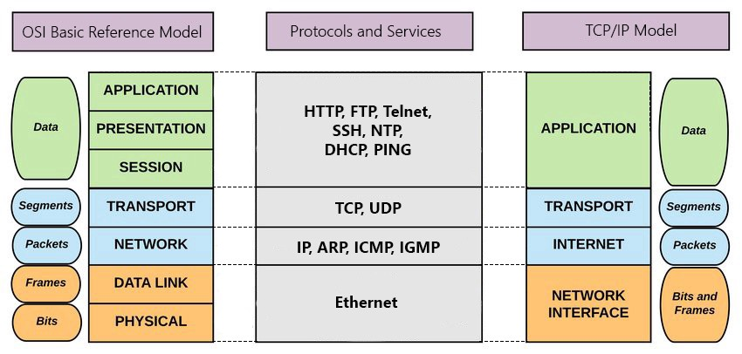LAYERS